Brian Nhan Thien Chung

ESS 162

**ESS162 Lab2: Patterns and controls on California’s Climate; Spatial patterns of climate across CA**

**This is a solo report lab**:

Lab is due online via Canvas at the beginning of Jan 22 class (11A). The rules for solo labs are: You may help your classmates with the data analysis, but the final lab report must be done alone, and lab reports with text or figures that have obviously been duplicated between students will be returned ungraded.

**Goals:**

You will be plotting and analyzing datasets that describe the spatial patterns of temperature and precipitation across California. The datasets are contained in a single zip file on the class website (Lab2.zip), which you will download and unzip into a single folder. You will be working with Google Earth Pro and Excel. The key datasets you will be analyzing are:

1. CAprecip2.kmz is a Google Earth kmz image of the mean annual precipitation across CA from PRISM, which uses estrapolated weather station data
2. CATmax.kmz is a Google Earth kmz image of the mean daily maximum air temperature across CA from PRISM
3. CAclimate.xls is a large excel file of the climate data for each 4 km square block across CA, which you will analyze to see the quantitative controls on climate across CA – this is a table of the same PRISM data contained in CAprecip2, CATmax, along with Ca_eco-l3, and a DEM (Digital Elevation Model, which shows the elevation for each location).
4. Decade2100-2010rcp85Tmaxclip…kmz is a Google Earth kmz image of the projected increase in daily maximum air temperature across the western US during 2090-2100 relative to 2000-2010. The data are for a bunch of downscaled climate models under the assumption that high emissions continue (RCP8.5 https://cal-adapt.org/).
5. Day Thermal IR.kmz is a Google Earth kmz image of the daytime surface temperature during last July from the Landsat 8 satellite
6. TIR locations.kmz is a series of pushpin locations that you will use with the Landsat TIR image to answer questions below
7. Ca_eco-l3.shp and Census_tract_clipped_2.shp are the ecoregion and census tract level datasets we looked at last week

**Tools, steps and commands – same deal as last week**

Download by clicking on the file

Right click and extract all to unzip the files

You will see a bunch of additional files when you unzip things that have similar same but different extensions (the extension comes after the period in the name – it indicates the file type). You will need to keep all of these files in the folder, though you won’t directly use them.

Google Earth Pro

Open and familiarize yourself with the following the kmz files: CAprecip2.kmz, CATmax.kmz, Decade2100-2010rcp85Tmaxclip…kmz, Day Thermal IR.kmz, TIR locations.kmz

These should already have their own embedded style templates and should open directly into Google Earth. Blue means cooler/wetter and red means warmer/drier.

Excel

Open CAclimate.xlsx

Important columns are: Latitude (A), Longitude (B), Ecoregion (C, code is on the right), annual mean precipitation (E, mm/yr), annual nighttime temperature (F, oC), and annual daytime temperature (G, oC).

Important things you will need to know how to do are:

Sort - for example identify the highest location in CA

Filter - for example identify the just one ecoregion such as the central valley (ecoregion 7)

Sort + filter - for example identify the lowest location in one ecoregion such as the central valley (ecoregion 7)

Scatter plot - for example see the relationship between elevation and temperature

Filter and Scatter plot - for example see how elevation varies with longitude within a latitude band of 36.0 to 36.5oN

**Writeup**

**Include Google earth images for CAprecip2.kmz, CATmax.kmz, Decade2100-2010rcp85Tmaxclip…kmz**

CATprecip2.kmz

CATmax.kmz

Decade2100-2010rcp85Tmaxclip…kmz

**In Google Earth, rank the 5 pushpin sites from coolest to warmest T in the Day Thermal IR.kmz and TIR locations.kmz files and explain what causes this order**

In order from coolest to warmest, the sites are: 2, 4, 3, 1, 5. Site 2 is the coolest because it is much closer to the coast than the other sites, and so it is cooled off more by the sea breeze than the other sites. As the daytime sea breeze moves inland, the breeze heats up and rises, preventing the more inland areas from being cooled. Site 4 is the 2nd coolest because, although it isn’t affected much by a sea breeze, (1) it is at a relatively higher altitude than all sites except for site 3 (temperatures decrease as altitude increases) – which allows it to be cooler than sites 1 & 5 and (2) it is on a North-facing slope, allowing it to receive less sunlight than site 3 and, therefore, be at a lower temperature than site 3. Site 3 still has a lower temperature than sites 1 & 5 by virtue of being at a higher altitude. Although site 1 & site 5 are both at similar altitudes, site 5 has a higher daytime temperature due to being in the rain shadow of the Peninsular Ranges. In this position, it receives sinking air that originates from the sea that drops precipitation in the process of rising over the Peninsular Ranges; after rising over the Peninsular Ranges, this sinking air then compresses as it sinks. As it compresses, it heats up, and this compression, combined with some loss of water via precipitation on the western side of the Peninsular Ranges, makes the air unsaturated, making the air heats up at the high dry adiabatic lapse rate of 10C/km as it sinks, forcing the region that it descends into – which includes site 5 – to have a higher daytime temperature than site 1 and all the other sites.

**Working with the file CAclimate.xlsx, identify and include Google Earth images of the coldest, driest and wettest locations in CA.**

Coldest location

Driest location

Wettest location

**Create a plot to see how precipitation varies with latitude along CA’s coast (just eco regions 1 and 12 and at elevations 0 - 200 m). Include this plot and describe what is causing this trend.**

**I created the following figures in Python due to my inability to make figures in Excel**

There is a fairly consistent positive correlation between latitude and precipitation along the coast. As the Northern Hemisphere exits the Autumnal Equinox and enters its winter, the polar front moves south and covers Northern California first before entering Southern California. As the Northern Hemisphere exits its winter and the Earth enters its Spring Equinox position, the polar front moves back north, exiting Southern California first before exiting Northern California. As a result, the polar front lingers for longer over Northern California, resulting in a longer rainy season that results in higher precipitation in Northern California.

**Create a plot to see how maximum day temperature varies with latitude within CA’s central Valley (just eco region 7 and at elevations 0 - 200 m). Include this plot and describe what is causing this trend.**

There is a consistent decreasing trend in maximum temperature as latitude increases before reaching its lowest at roughly between 37.5 & 38.5 degrees North. Afterwards, as latitude increases, temperature stays fairly constant. The initial decreasing trend can be explained by the decreasing intensity of solar radiation as latitude increases due to beam spreading of solar radiation: as latitude increases, solar radiation spreads over larger surface areas, resulting in decreasing intensity of solar radiation. This results in a fairly consistent decreasing trend that bottoms out at between 37.5 & 38.5 degrees North; in this latitude band, there is a gap in the California Coastal Ranges, which allows sea breezes to enter the Central Valley through this gap to cool locations in the Central Valley that are closest to the coast, resulting in a tremendous drop in daytime temperature in these locations compared to locations in the Central Valley that are farther inland and/or farther north or south.

As latitude increases past 38.5 degrees North, maximum temperature stays constant. The lack of an increasing trend with latitude past 38.5 degrees North can be explained by beam spreading of solar radiation that decreases solar radiation with latitude, preventing the maximum temperature from increasing with latitude. The lack of a decreasing trend can be explained by the diminishing effect of a sea breeze with latitude; as latitude increases past 38.5 degrees North, these locations are further and further away from the sea breeze that came from the gap between the Coastal Ranges, and so the daytime cooling effect by the sea breeze decreases with latitude, preventing maximum temperature from decreasing with latitude. Thus, these 2 phenomena (beam spreading of solar radiation which prevents an increase in maximum temperature with latitude and the diminishing effect of the sea breeze which prevents a decrease in maximum temperature with latitude) “cancel” each other out, resulting in fairly constant maximum temperature with latitude.

**Create a plot to see how elevation varies with longitude across CA at 36.8 to 37.2 latitude. Include this plot and describe what it shows (maybe refer to Google earth to make the link between latitude/longitude and what is actually there.**

The Coastal Ranges can be seen along the longitude band 121 – 122.5 degrees West with a sudden increase in elevation that never went past 1000 m as one travels eastward from the coast. Elevation then bottoms out near sea level between 120 – 121 degrees West; this is where the Central Valley occurs. Elevation then increases again as one travels eastward, and this increase in elevation is due to the presence of the Sierra Nevadas mountain range. As one travels eastward past the Sierras, elevation then decreases due to the presence of basins that are still relatively high in altitude but lower than the Sierras.

**Create a plot to see how temperature varies with longitude across CA at 36.8 to 37.2 latitude. Include this plot and describe what is causing this trend.**

This is a figure of maximum temperature vs longitude. Temperatures are relatively low towards the west where the Coastal Ranges are. As one travels eastward past the Coastal Ranges, elevation decreases, which is accompanied by an increases in maximum temperature before leveling out in the longitude band 120 – 121 degrees West. This is where the Central Valley is, and its higher temperature than the Coastal Ranges and the Sierra Nevadas can be explained by (1) its lower elevation and (2) being blocked from a sea breeze by the Coastal Ranges in this latitude band. The blocking of the sea breeze prevents the Central Valley in this latitude band from being cooled down by the sea breeze during the day, resulting in higher temperatures than the Coastal Ranges and the Sierras. As one continues traveling eastward, elevation increases, resulting in a fairly continuous drop in temperature with elevation. Eventually, temperature reaches its lowest point towards the summit of the Sierras in this range; temperatures here are lower than temperatures on the Coastal Ranges by virtue of the summits of the Sierras being much higher in elevation than the summits of the Coastal Ranges. As one travels eastward past the Sierras, temperatures generally increase due to the decreasing elevation as one travels past the Sierras.

**Create a plot to see how precipitation varies with longitude across CA at 36.8 to 37.2 latitude. Include this plot and describe what is causing this trend.**

Precipitation reaches one of its local maximums in this latitude band near the coast due to the presence of the Coastal Ranges, which orographically lifts humid air from the Pacific Ocean, resulting in high precipitation along the Coastal Ranges. Although the Coastal Ranges are fairly similar in elevation as one travels eastward along this latitude band, precipitation still decreases as one travels eastward on the Coastal Ranges; this is because the westward edge of the Coastal Ranges is the edge that causes orographic lifting, allowing it to receive more precipitation than the eastern edge of the Coastal Ranges. As one then exits the Coastal Ranges when traveling East, precipitation reaches one of its local minimums in the Central Valley; as air descends the Coastal Ranges, the air expands and heats up adiabatically, resulting in decreased annual precipitation in the Central Valley. When one continues traveling eastward and exits the Central Valley to start ascending the Sierras, precipitation starts increasing again as as air masses expand and cool adiabatically with increasing elevation, causing precipitation to increase with elevation. Eventually, precipitation reaches its second local maximum at the summit of the Sierras in this latitude band. Precipitation here is similar to precipitation on the western edge of the Coastal Ranges despite the fact that the Sierras have much higher summits than the Coastal Ranges; this is because the Coastal Ranges had already caused a significant amount of precipitation, and what little water vapor remaining must rise to much higher altitudes to result in similar precipitation as the much lower Coastal Ranges. Precipitation then decreases very drastically as one travels eastward past the Sierras, reaching its absolute minimum eastwards of the Sierras in the basins. Despite these basins being at higher elevations than the Central Valley, these basins receive less precipitation than the Central Valley. That is because very little water vapor remains after being precipitated out by 2 mountain ranges.

**In Google Earth, combine the data layers Ca_eco-l3.shp, Census_tract_clipped_2.shp and Decade2100-2010rcp85Tmaxclip…kmz. Identify 2 ecoregions where warming is expected to be especially pronounced. Identify 3 ecoregions where warming is expected to be less severe. Identify the area in CA where particularly high levels of warming and high population densities coincide – include the Google earth images for this area.**

The ecoregions where warming is especially pronounced are, in order of more severe to less severe: (1) Central Basin and Range and (2) the Sierra Nevadas. The ecoregions where warming is expected to be the least severe are: (1) the Coast Range, (2) Southern California/Northern Baja Coast, and (3) the Klamath Mountains.

The following areas are where high levels of warming and high population densities collide:

Bishop, CA

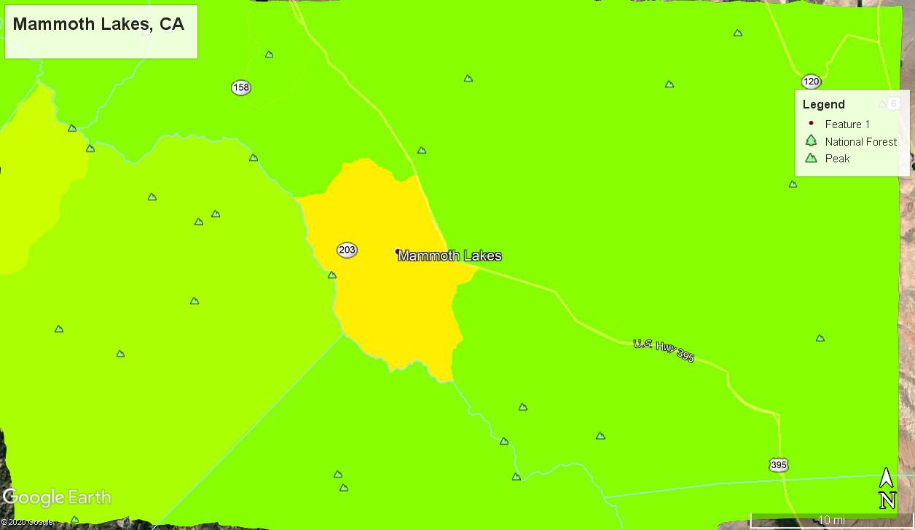

Mammoth Lakes, CA

Fresno, CA

All 3 of these locations are on the eastern side of California in the vicinity of the Sierras. This region is projected to witness the most dramatic increases in temperature.